Prince
25M0809

EXERCISES -

1. We will begin with Linux shell commands used to examine the processes running in a system.
- List all processes running in the system. Explore the different styles of displaying the output, e.g., BSD syntax vs. standard (ps) syntax.
ANS →

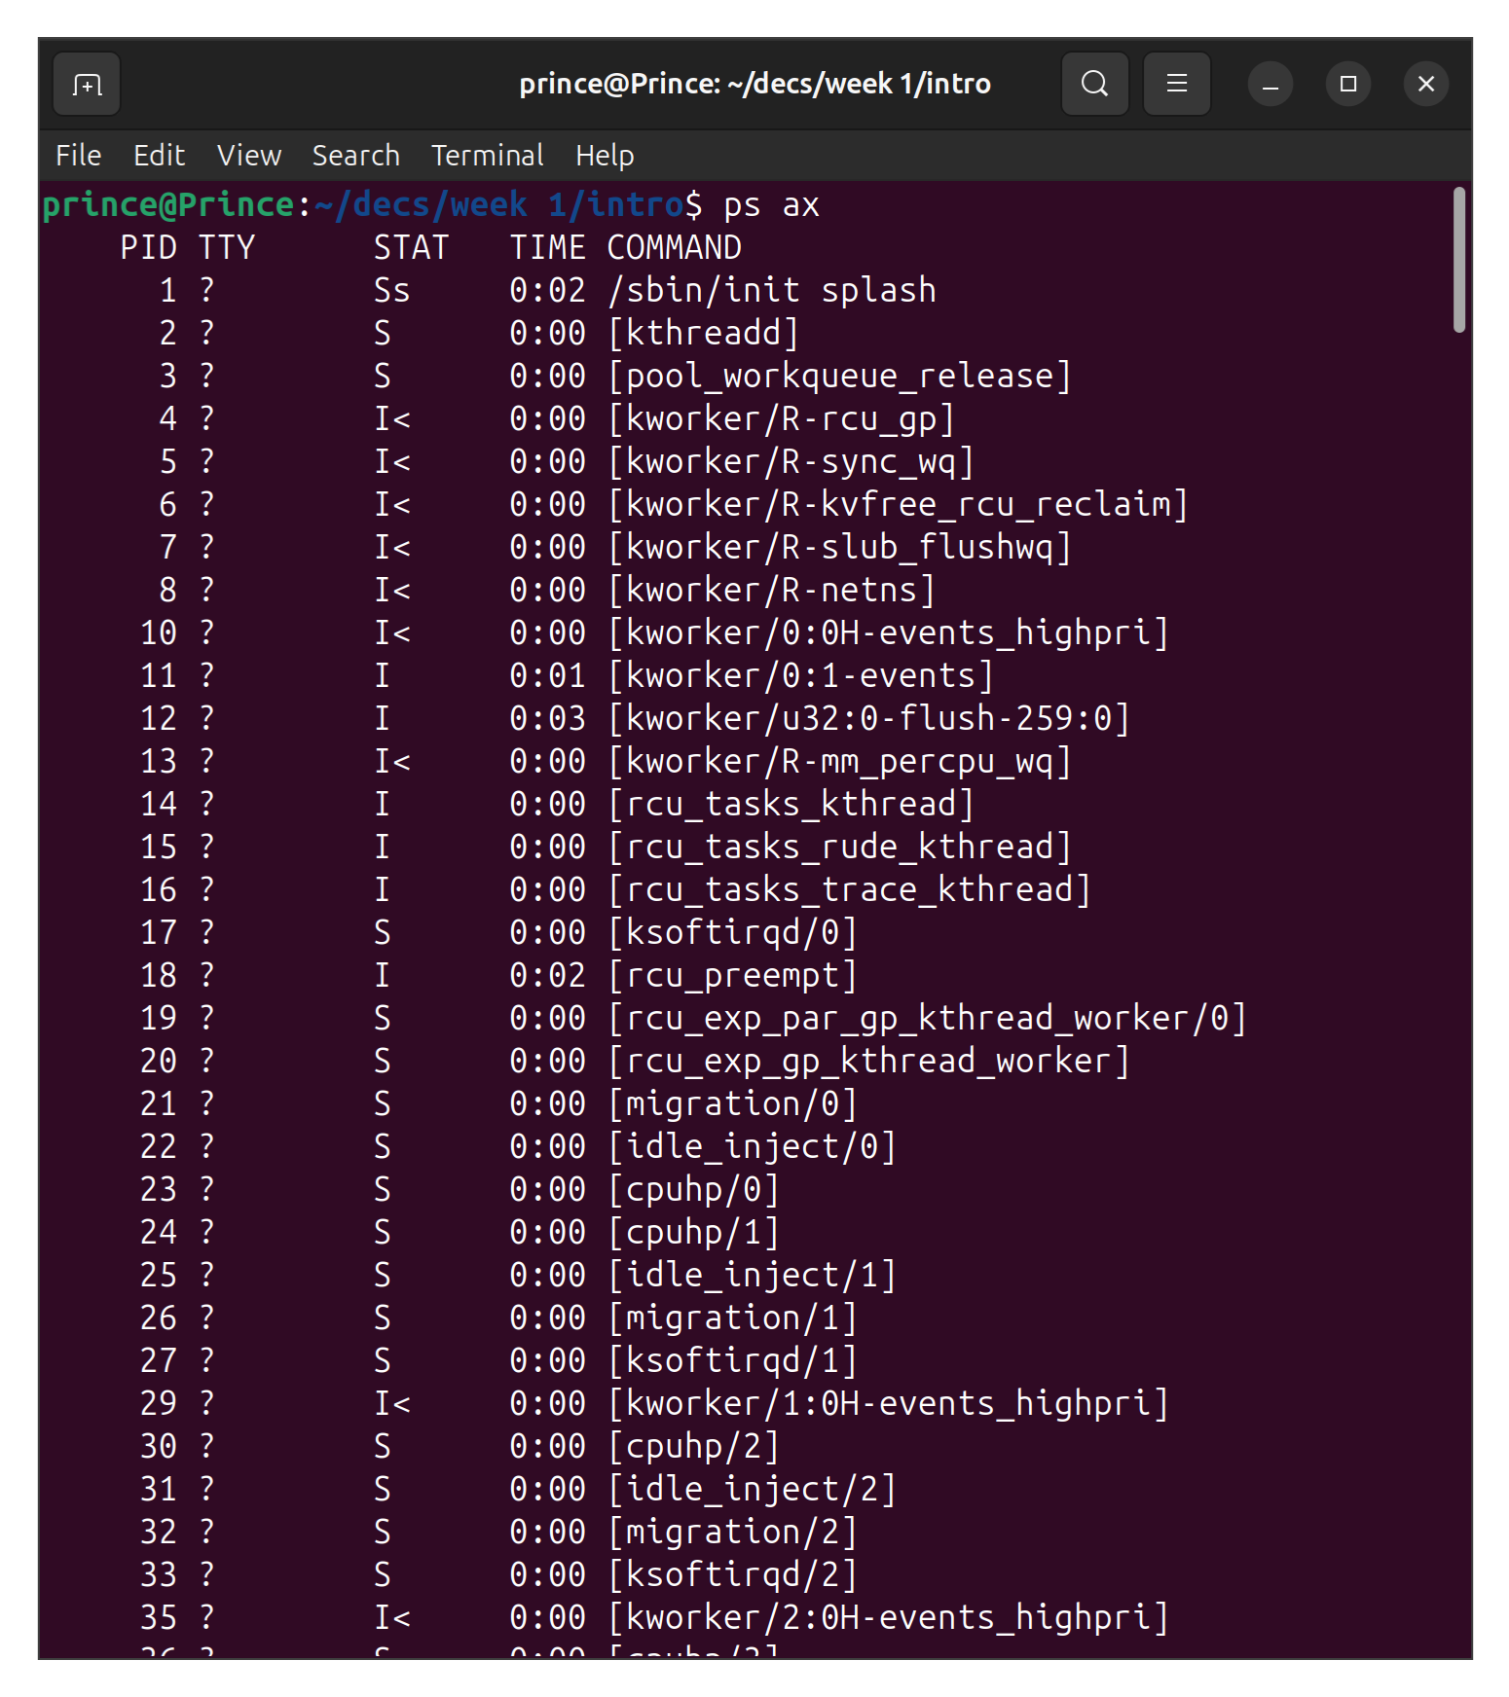
BSD Syntax → ps ax

Standard Syntax → ps -e

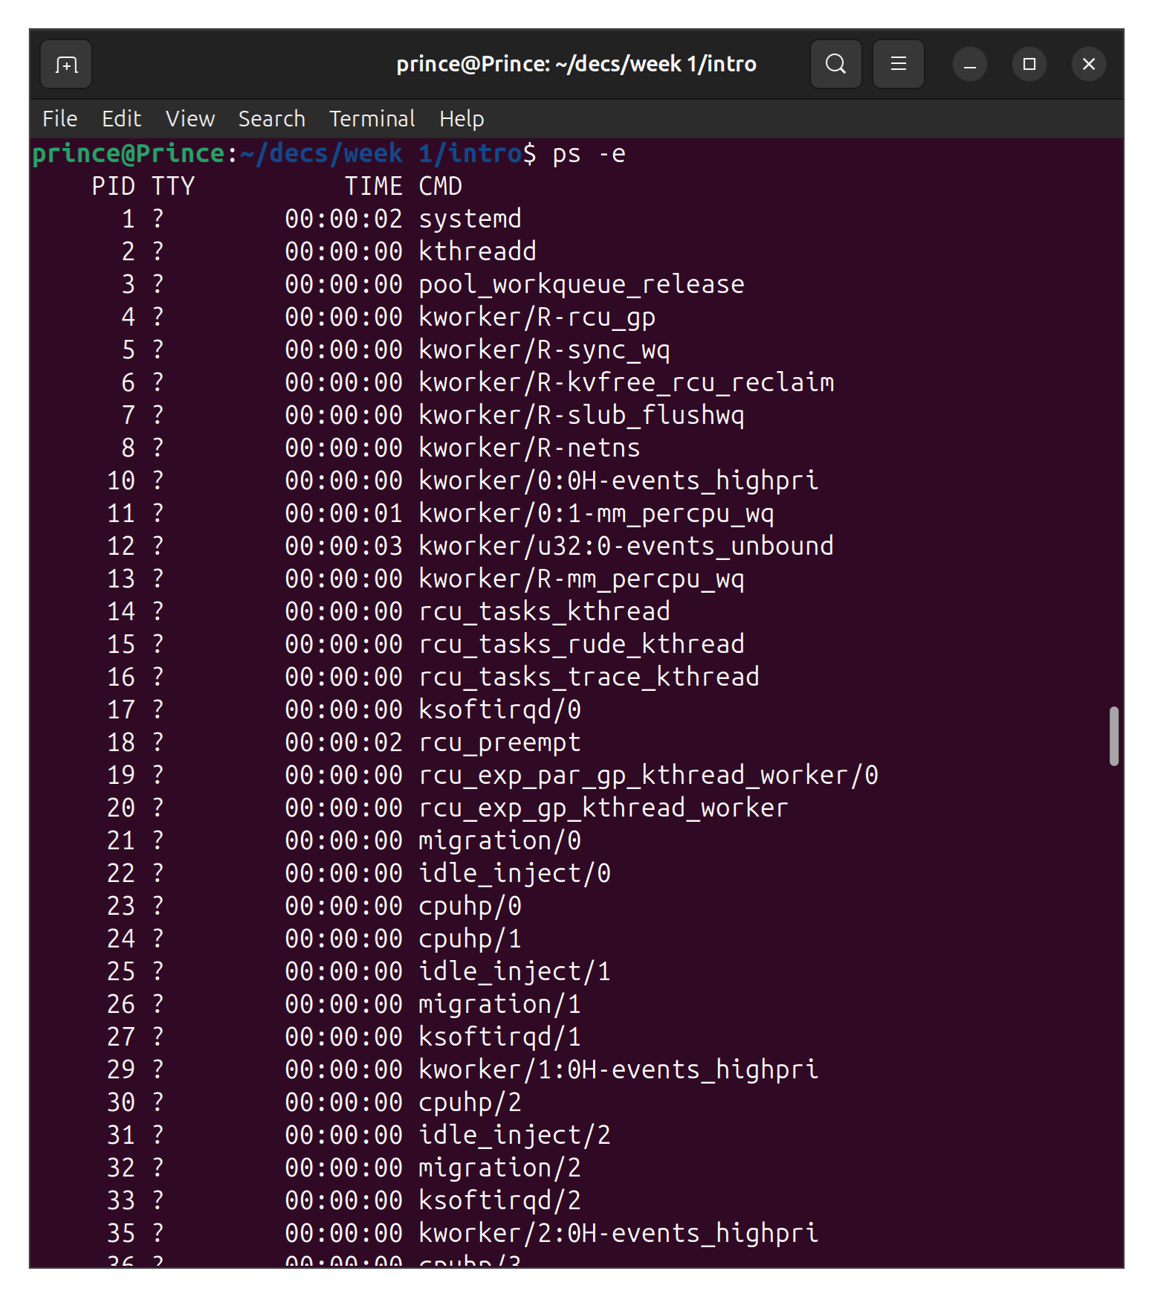

- Print a process tree for all processes running in the system.
ANS →
Command → pstree

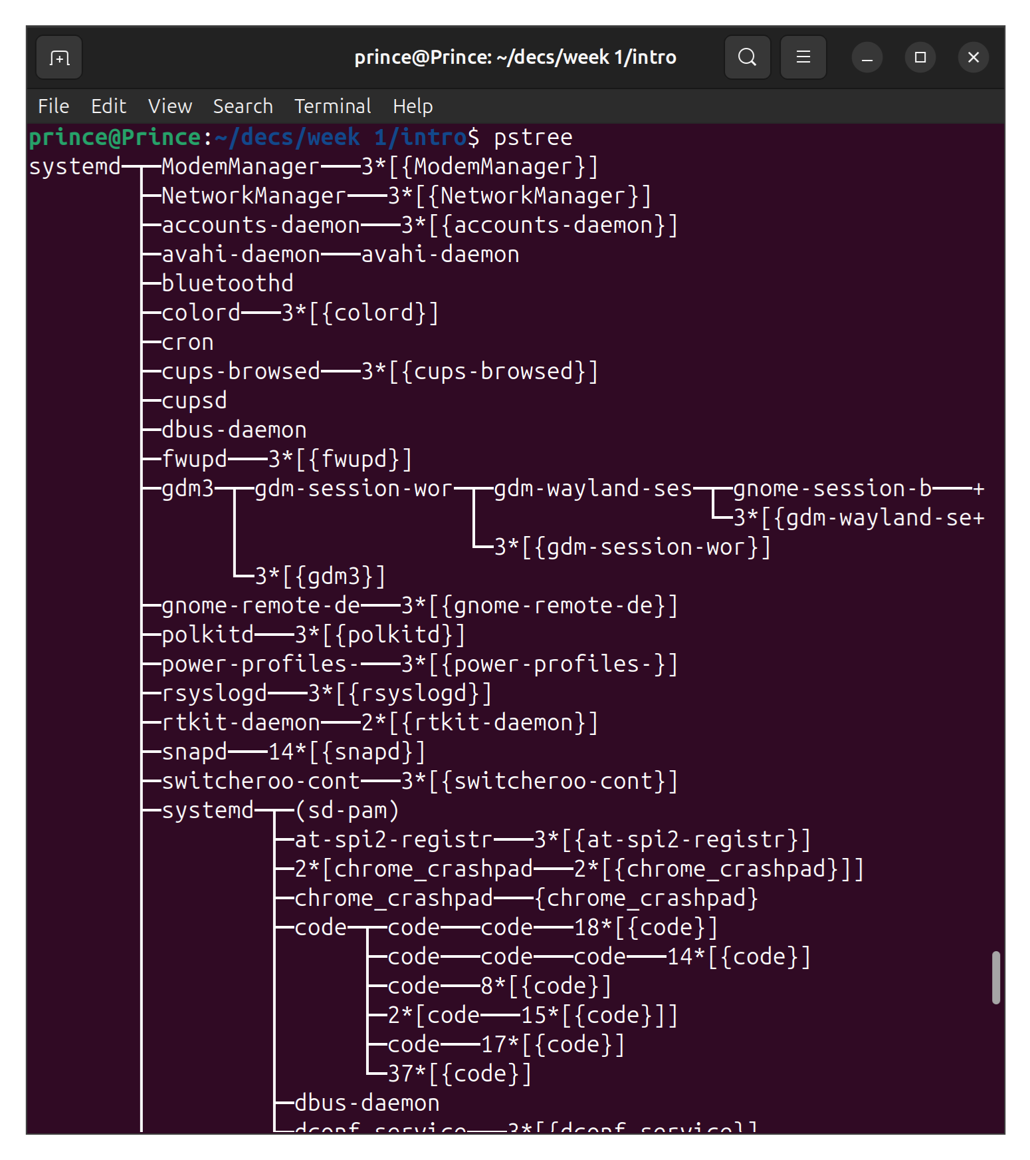

- List the pid, ppid, state, command, for all process running in the system.
ANS →
Command → ps -eo pid,ppid,state,cmd
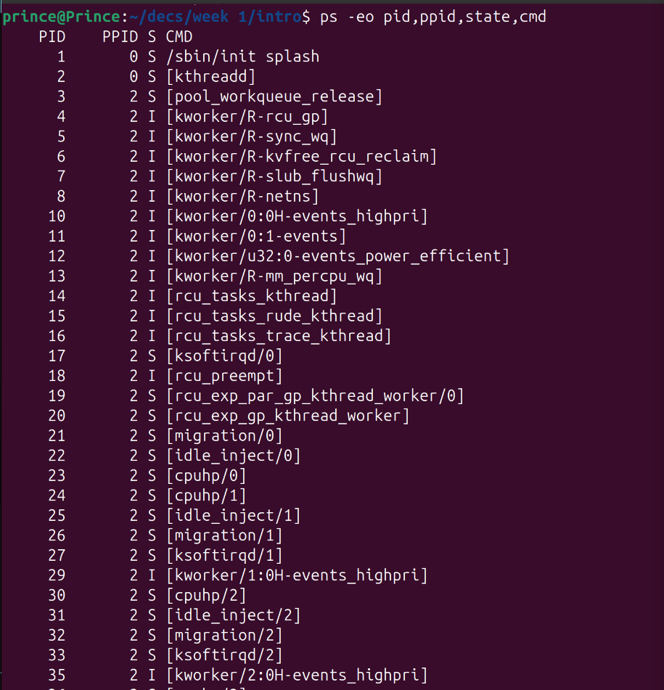

- List the pid, ppid, and name of the command of process with pid 123 (or any PID).
ANS →
Command → ps -o pid,ppid,comm -p PID
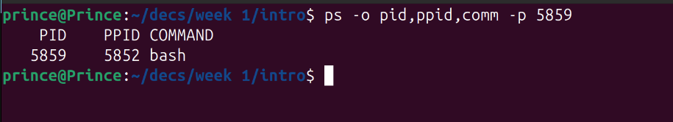

- Print the process tree of a process with pid 123 using ascii characters.
ANS →
Command→ pstree -p PID

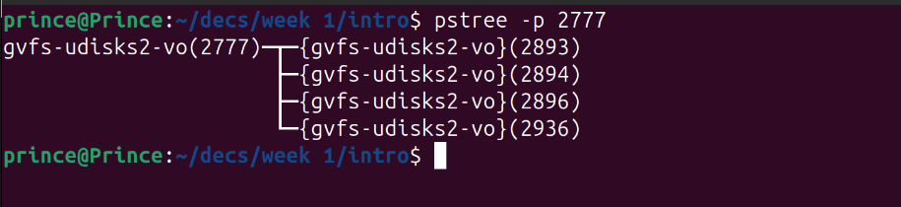

2. Answer the following questions by looking at the files in the proc filesystem, and the outputs of the lscpu, uname, uptime commands on your system.

- How many CPUs / cores / processors does your machine have? What is the frequency of each processor? What is the architecture of your CPU?
ANS →
Command → lscpu
Cores = 8
Frequency →
CPU max MHz: 4200.0000
CPU min MHz: 400.0000
Architecture = x86_64
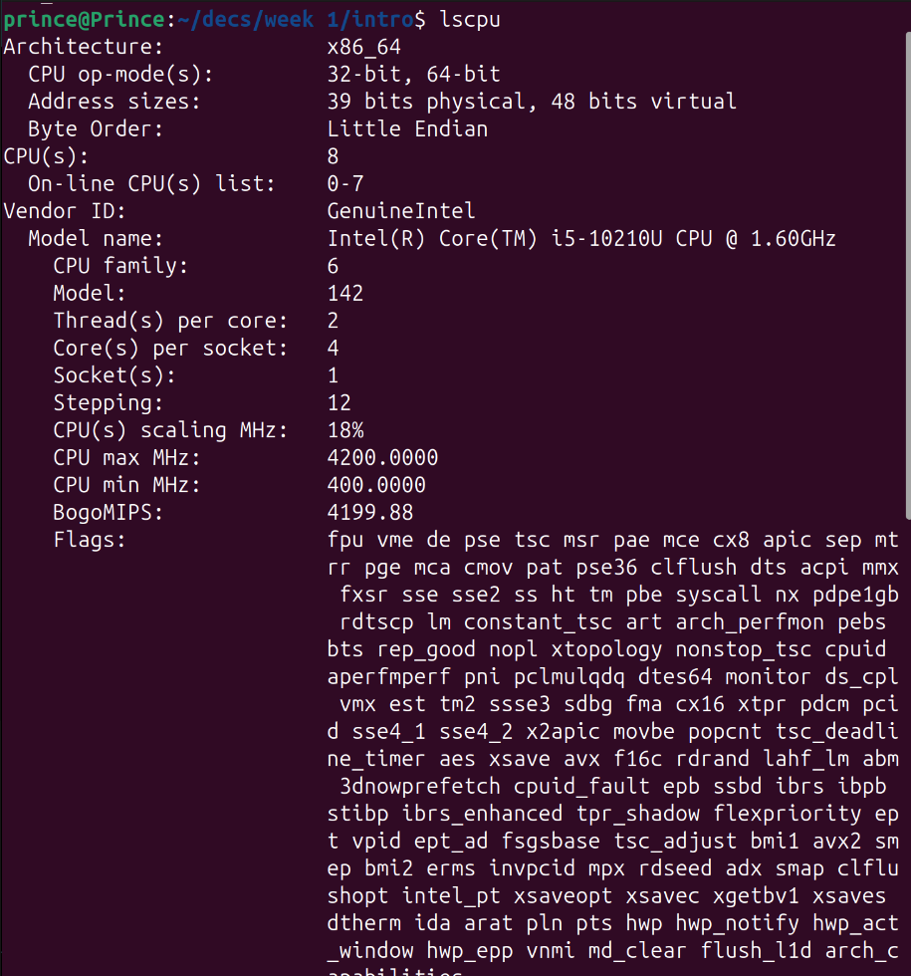

- How much physical memory does your system have? How much of this memory is free?
ANS →
Command → free
Total memory = 7405204
Free memory = 403040

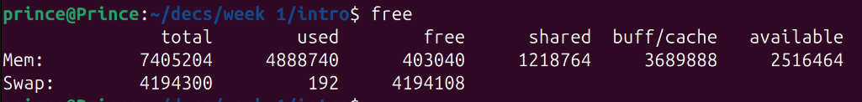

- For how long has your system been running? What is total number of context switches since the system booted up?
ANS →
Command → uptime
Command →uptime -p
Up time = 2 hours, 58 minutes

Command → cat /proc/stat | grep ctxt
Context switches = 15227117

- What is name of your operating system? What is the kernel version?
ANS →
Command → uname -o
Operating System = GNU/Linux

Command → uname -v
Kernel version = #27-Ubuntu SMP PREEMPT_DYNAMIC Tue Jul 22 17:01:58 UTC 2025

3. In this question, we will understand how to monitor the status of a running process using the top command. Compile the program cpu.c given to you and execute it in the shell. $ gcc cpu.c -o cpu $ ./cpu This program runs in an infinite loop without terminating. Now open another terminal, run the top command and answer the following questions about the cpu process.

- What is the PID of the process running the cpu command?
ANS →
Command → top
PID = 11738

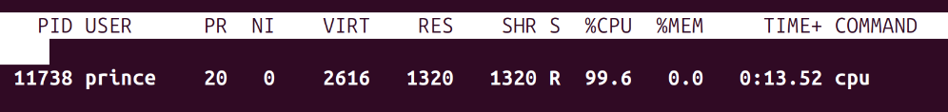
- How much CPU and memory does this process consume?

ANS →
CPU = 99.9%
Memory = 0%

- What is the current state of the process? For example, is it running or in a blocked state or a zombie state?

ANS →
State = Running

4. In this question, we will understand how the Linux shell (e.g., the bash shell) runs user commands by spawning new child processes to execute the various commands.

- Compile the program cpu-print.c given to you and execute it in the bash or any other shell of your choice as follows. $ gcc cpu-print.c -o cpu-print $ ./cpu-print
This program runs in an infinite loop printing output to the screen. Now, open another terminal and use the ps command with suitable options to find out the pid of the process spawned by the shell to run the cpu-print executable.

ANS →
Command → ps -e | grep cpu-print
PID = 11875

- Find the PID of the parent of the cpu-print process, i.e., the shell process. Next, find the PIDs of all the ancestors, going back at least 5 generations (or until you reach the init process).
ANS →
Command → ps -o pid,ppid,cmd -p PID
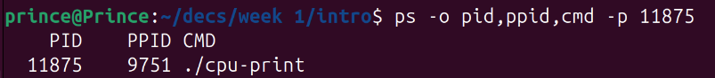
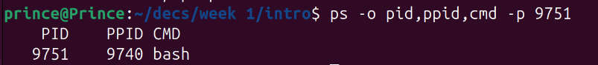
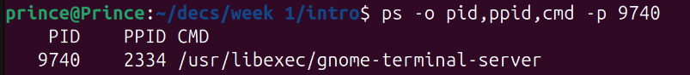
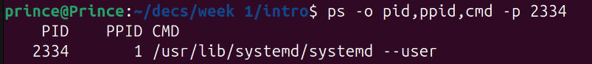
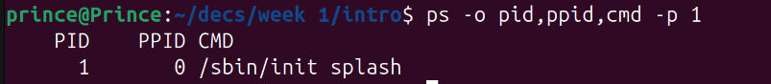
- Using the pstree command, print the process tree of the shell process that is running your cpu-print program.

ANS →
Command → pstree -p PID

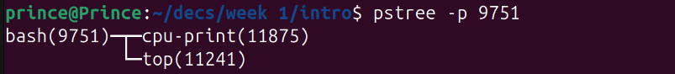

- Now, stop the execution of the cpu-print executable. Run a long background command, e.g., sleep 10000 & on your shell. Restart the long cpu-print process in the foreground again. Visualize the process tree of your shell again.

ANS →
Commands → pstree -p PID

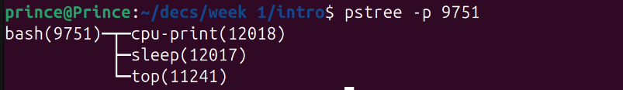

5. When you type in a command into the shell, the shell does one of two things. For some commands, executables that perform that functionality already come with your Linux kernel installation. For such commands, the shell simply invokes the executable to run the command. For other commands where the executable does not exist, the shell implements the command itself within its code. Consider the following commands that you can type in the bash shell: cd, ls, ps, sleep, history. Which of these commands already exist as executables in the Linux kernel directory tree, and which are implemented by the bash code itself? If the executable already exists, what is the pathname of the executable file? You may use the which command to help you.

ANS →

Commands in kernel = cd , history

Commands implemented in bash code →
- ls = /usr/bin/ls
- ps = /usr/bin/ps
- sleep = /usr/bin/sleep

